Goal: The goal is to get a job or internship

Features:Company Website Link

Descriptions

Comparing View

Tabs on top

Search bar

Different modules

Salary bar

Sketch 1

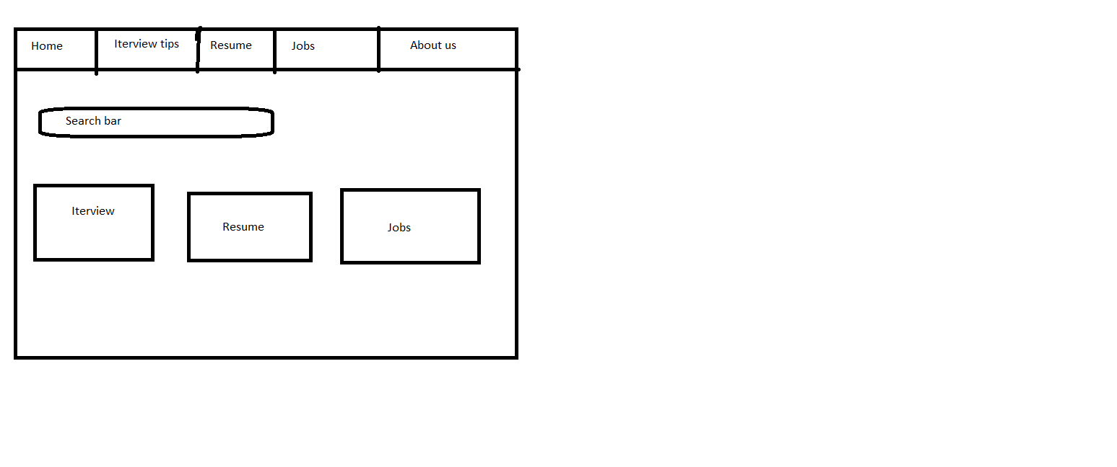

Sketch 2

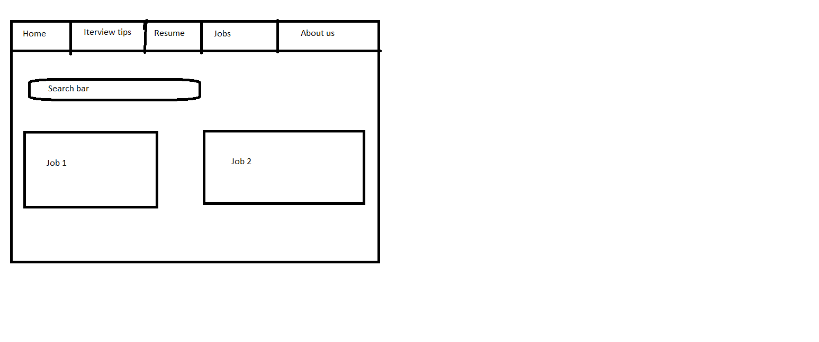

Sketch 3

